05_ Payroll Input & Validation (HK)
Process Definition Document

Version Control#

Date | Author | Changes | Version
22/09/2025 |  | Initial | v1.0
17/11/2025 |  | update | v1.1
20/11/2025 |  | update | v2.0

Content

Content 1
1. Introduction 2
1.1. Purpose of the document 2
1.2. Process key contact 2
1.3. General Rules & Conventions 2
2. As-Is process description 3
2.1. Process Overview 3
2.2. Applications used in the process 3
2.3. As-Is Process map 3
High Level As-Is Process Map: 4
Output File Template: 4
2.4. Detailed As-Is Process Steps 4
2.4.1. Subprocess 1 4
2.4.2. Subprocess 2 16
2.4.3. OUTPUT 39
2.5 Additional sources of process documentation 39
3. Sign-Offs 39

Introduction

Purpose of the document
The Process Definition Document outlines the business process chosen for automation using Robotic Process Automation (RPA) technology.
The INPUT part process captures data from various source tables or calculates the data and fills it into the Flexiform final output table .
The VALIDATION part process is to grab specific data from the source data table, align and compare it in the order of the benchmark table, and finally output an Excel file containing two worksheets to verify the integrity and consistency of the data.

Process key contact
The specifications document includes concise and complete requirements of the business process and it is built based on the inputs provided by the process Subject Matter Expert (SME)/ Process Owner.
The Process Owner is expected to review it and provide sign off for accuracy and completion of the steps, context, impact and a set of process exceptions. The details are to be included in the table below.
Role | Name | Email | Notes
Process SME
Process owner

General Rules & Conventions
To ensure that certain processing rules can be flexibly adjusted according to user requirements throughout the automated process,【config】and 【额外表】 are set up for users to define the rules.

As-Is process description

Process Overview
General information about the process selected for RPA prior to automation.
# | Item | Description
1 | Process full name | Payroll Input & Validation (HK)
2 | Process Area | China
3 | Department | HR
4 | Process schedule and frequency | NA
5 | Process execution time | NA
6 | Peak period (s) | NA
7 | Transaction Volume During Peak period | NA
8 | Total # of FTEs supporting this activity
9 | Input data
10 | Output data
*Add more rows to the table to include relevant data for the automation process. No fields should be left empty. Use “n/a” for the items that don`t apply to the selected business process.

Applications used in the process
The table includes a comprehensive list of all the applications that are used as part of the process to be automated to perform the given steps in the flow.
# | Application name & version | System Language | Environment/Access method | Comments
1 | Excel | English/ Chinese
*Add more rows to the table to include the complete list of applications.

As-Is Process map

High Level As-Is Process Map:
This chapter depicts the As-Is business process at a High Level to enable developers to have a high-level understanding of the current process.
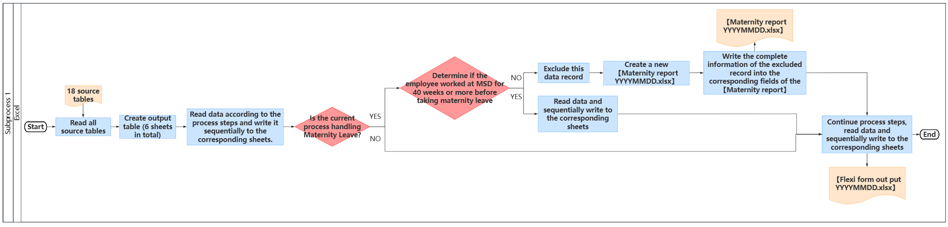
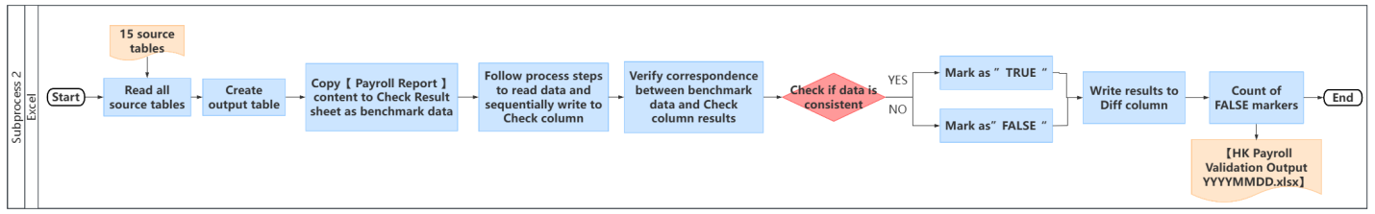

Output File Template:

Detailed As-Is Process Steps

Subprocess 1

Input
Obtain the data source by retrieving the table file named as follows from the specified location "input folder address"：
- 1263 ADP flexiform template_HK_NewHire
- 1263 ADP flexiform template_HK_ DataChange
- 1263 ADP flexiform template_HK_Comp
- 1263 ADP flexiform template_HK_Termination
- 1263 ADP flexiform template_HK_Variable
- 1263 ADP flexiform template_HK_ Attendance
- One time payment report
- Inspire Awards payroll report
- Employee_Leave_Transactions_Report
- EAO Summary Report_YYYYMM
- Workforce Detail - Payroll-AP
- Merck Payroll Summary Report——xxx（Two employees will each have their respective tables)
- SIP QIP
- MSD HK Flex_Claim_Summary_Report
- RSU Dividend global report
RSU Dividend EY report
- AIP Payouts Payroll Report
- 额外表

Input File Template:

初始化
Create an Excel file named 【Flexi form out put YYYYMMDD.xlsx】, where "YYYYMMDD" represents the current execution date. Create six sheets within it named 【NewHire】【InformationChange】【SalaryChange】【Termination】【Attendance】and【VariablePay】.
Output the detailed specifications as follows:
- 【New Hire】【Information Change】【SalaryChange】【Termination】【Attendance】【VariablePay】
● Content: To fully and separately replicate the raw data from the input files: 【1263 ADP flexiform template_HK_NewHire】【1263 ADP flexiform template_HK_ DataChange】【1263 ADP flexiform template_HK_ Comp】【1263 ADP flexiform template_HK_Termination】【1263 ADP flexiform template_HK_ Attendance】and 【1263 ADP flexiform template_HK_Variable】.

- 【VariablePay】
● Content: Based on the raw data of the 【VariablePay】 sheet, insert six new columns to the right of the "Adjustment of Parental Paid Time Off (PPTO) payment" column. These new columns are: IA Pay Split, MPF Relevant Income Rewrite, MPF VC Relevant Income Rewrite, Paternity Leave payment adjustment, PPTO EAO Rate input, and Flexible benefits.

- 【Attendance】【VariablePay】
● Content: Populate the data retrieved from other tables based on the corresponding Employee Code.
● Retrieval Rules:
- Match based on Employee Code to obtain values from specific rows and columns, or to calculate and derive specific values, which are then written into designated cell positions in the 【Attendance】 or 【VariablePay】 sheets.
- If certain data cannot be found in the other tables (including the Employee Code itself) but exists in the 【Attendance】 or 【VariablePay】 sheets, the corresponding cell positions in the 【Attendance】 or 【VariablePay】 sheets should be left blank.
- If certain data exists in the other tables (including the Employee Code) but is not included in the 【Attendance】 or 【VariablePay】 sheets, this extra data should be appended sequentially to the end of the 【Attendance】 or 【VariablePay】 sheets. (For example, if the 【VariablePay】 sheet has 20 rows of data, and the process retrieves 30 rows—where 20 rows have matching Employee Codes in the 【VariablePay】 sheet and the remaining 10 rows do not—then the Employee Codes for these 10 extra rows should be written into rows 21 to 30 of the 【VariablePay】 sheet. Subsequent sub-processes will then retrieve other data and populate the corresponding cells based on the Employee Code.)

写入Flexi form out put

RPA report
Copy the 【1263 ADP flexiform template_HK_NewHire】【1263 ADP flexiform template_HK_DataChange】【1263 ADP flexiform template_HK_Comp】【1263 ADP flexiform template_HK_Termination】and【1263 ADP flexiform template_HK_Variable】 tables to the [NewHire] [InformationChange] [SalaryChange] [Termination] and [VariablePay] sheets respectively in the 【Flexi form out put YYYYMMDD.xlsx】 file.

One time payment report
First, filter the 【One time payment report】 to exclude all records where [One-Time Payment Plan] is either Inspire Points Value or Inspire Cash Award. Then, apply a further filter to keep only records where [Completed On] falls between the day after the previous month's cut-off date and the current month's cut-off date, and where [Scheduled Payment Date] belongs to the previous month.

Next, from the filtered dataset, extract the full set of Employee ID and Actual Payment – Amount for records where [One-Time Payment Plan] is one of the following:
Lump Sum Merit, Sign On Bonus, Retention Bonus, Referral Payment, Manager of the Year Award, MD Award, Employee Award, New Year's Allowance, Cash award, SIP to AIP Transition.

If multiple Actual Payment – Amount values exist for the same Employee ID under the same One-Time Payment Plan, sum these amounts to ensure a single Actual Payment – Amount value per Employee ID per plan type.

Finally, map the Employee ID to the Employee Code in the 【VariablePay】 sheet and write the corresponding summed Actual Payment – Amount values into their designated rows and columns.

One time payment report | Flexi form out put - VariablePay
Actual Payment – Amount（Lump Sum Merit） | Lump Sum Bonus
Actual Payment – Amount（Sign On Bonus） | Sign On Bonus
Actual Payment – Amount（Retention Bonus） | Retention Bonus
Actual Payment – Amount（Referral Payment） | Referral Bonus
Actual Payment – Amount（Manager of the Year Award） | Manager of the Year Award
Actual Payment – Amount（MD Award） | MD Award
Actual Payment – Amount（Employee Award） | Employee Award
Actual Payment – Amount（New Year's Allowance） | Red Packet
Actual Payment – Amount（Cash award / SIP to AIP Transition） | Other Allowance

Inspire Awards payroll report
Extract the full set of Employee ID and Actual Payment – Amount values from the 【Inspire Awards payroll report】 where [One-Time Payment Plan = Inspire Points Value] and [One-Time Payment Plan = Inspire Cash]. If duplicate Employee IDs are found, sum their Actual Payment – Amount values to ensure each Employee ID receives only one consolidated Actual Payment – Amount value per One-Time Payment Plan type.

Map the Employee ID to the Employee Code in the 【VariablePay】 sheet and write the corresponding values into their designated rows and columns.

Inspire Awards payroll report | Flexi form out put - VariablePay
Actual Payment – Amount（Inspire Points Value） | InspirePoints
Actual Payment – Amount（Inspire Cash） | Inspire Cash

Employee_Leave_Transactions_Report
Extract the full set of WIN, FROM DATE, TO DATE, APPLY DATE, and APPROVAL DATE from the 【Employee_Leave_Transactions_Report】 where [STATUS = Approved]. Using the combination of WIN & FROM DATE & TO DATE & APPLY DATE & APPROVAL DATE as a unique identifier, compare this data with the previous month's records to identify new leave entries (i.e., those that have not been paid). For these newly identified leave records, apply the following calculation logic:
- Annual Leave:
Extract the full set of WIN, FROM DATE, TO DATE, and TOTAL DAYS from the newly identified (i.e., unpaid) leave records where [LEAVE TYPE = Annual Leave], and convert the TOTAL DAYS values to a numeric format. If the FROM DATE and TO DATE span across multiple calendar months, automatically split the record into multiple entries, with each entry containing only the actual number of days falling within a single calendar month.

When calculating the TOTAL DAYS for Annual Leave spanning months, exclude weekends and public holidays in Hong Kong.

- For records occurring in the current or previous month:
Map the WIN to the Employee Code in the 【Attendance】 sheet and write the corresponding TOTAL DAYS values into their designated rows and columns.

Employee_Leave_Transactions_Report | Flexi form out put - Attendance
TOTAL DAYS（Current month） | Days_AnnualLeave
TOTAL DAYS（Current month） | Days_AnnualLeaveForDeduction
TOTAL DAYS（Previous month） | Days_AnnualLeave_LastMonth
TOTAL DAYS（Previous month） | Days_AnnualLeaveForDeduction_LastMonth

- For records dated before the previous month:
Retrieve the WEIN, AverageDayWage_12Month, NoPayLeaveCalculationBase, and DailySalary of the employee from the 【EAO Summary Report_YYYYMM】 sheet corresponding to the month in which the Annual Leave occurred. If the AverageDayWage_12Month is greater than the DailySalary, calculate the value as (AverageDayWage_12Month - DailySalary) × TOTAL DAYS (sum of Annual Leave days from before the previous month), referred to as "Annual Leave EAO Adj_Input".
Map the WIN to the Employee Code in the 【VariablePay】 sheet and write the Annual Leave EAO Adj_Input value into the corresponding row and column.

EAO Summary Report_YYYYMM | Flexi form out put - VariablePay
Annual Leave EAO Adj_Input | Annual Leave EAO Adj_Input

- A specific example is provided below:
Assuming the current month is November 2023, Employee A has a FROM DATE of 2023/09/30 and a TO DATE of 2023/11/01. After excluding 10 days of holidays and rest days from 2023/10/01 to 2023/10/10, the record should be split into the following three entries:
[FROM DATE = 2023/09/30, TO DATE = 2023/09/30, TOTAL DAYS = 1]
[FROM DATE = 2023/10/01, TO DATE = 2023/10/31, TOTAL DAYS = 21]
[FROM DATE = 2023/11/01, TO DATE = 2023/11/01, TOTAL DAYS = 1]

The corresponding relationship is shown in the table below:
Employee_Leave_Transactions_Report | Flexi form out put - Attendance
TOTAL DAYS=1（Current month） | Days_AnnualLeave
TOTAL DAYS=1（Current month） | Days_AnnualLeaveForDeduction
TOTAL DAYS=21（Previous month） | Days_AnnualLeave_LastMonth
TOTAL DAYS=21（Previous month） | Days_AnnualLeaveForDeduction_LastMonth

EAO Summary Report_YYYYMM | Flexi form out put - VariablePay
Annual Leave EAO Adj_Input =(AverageDayWage_12Month - DailySalary) *1 | Annual Leave EAO Adj_Input

- Sick Leave:
Extract the full set of WIN, FROM DATE, TO DATE, and TOTAL DAYS from the newly identified (i.e., unpaid) leave records where [LEAVE TYPE = Sick Leave], and convert the TOTAL DAYS values to a numeric format.

If the FROM DATE and TO DATE span across rest days (weekends), determine whether the period includes four consecutive working days. If not, exclude the record.

If the FROM DATE and TO DATE span across multiple calendar months, automatically split the record into multiple entries, with each entry containing only the actual number of days falling within a single calendar month.

If the condition of four consecutive working days is met, map the WIN to the Employee Code in the 【Attendance】 sheet and write the corresponding TOTAL DAYS values into their designated rows and columns.
(Example: If weekends are on 2023/12/2–2023/12/3 and 2023/12/9–2023/12/10, then:

Sick leave from 2023/12/1 to 2023/12/5 (5 days) has 3 working days → no sick leave payment.

Sick leave from 2023/12/7 to 2023/12/12 (6 days) has 4 working days → eligible for sick leave payment.)

- For records occurring in the current or previous month:
Map the WIN to the Employee Code in the 【Attendance】 sheet and write the corresponding TOTAL DAYS values into their designated rows and columns.

Employee_Leave_Transactions_Report | Flexi form out put - Attendance
TOTAL DAYS（Current month） | Days_SickLeave
TOTAL DAYS（Current month） | Days_SickLeaveForDeduction
TOTAL DAYS（Previous month） | Days_SickLeave_LastMonth
TOTAL DAYS（Previous month） | Days_SickLeaveForDeduction_LastMonth

- Records dated before the previous month:
Retrieve the WEIN, DayWage_Maternity/Paternity/Sick Leave, DailySalary, and Days_SickLeave of the employee from the 【EAO Summary Report_YYYYMM】 sheet corresponding to the month in which the Sick Leave occurred.
Calculate the value as: (DayWage_Maternity/Paternity/Sick Leave − DailySalary) × Days_SickLeave，and record it as "Sick Leave EAO Adj_Input".

If multiple Sick Leave EAO Adj_Input values exist for the same WEIN, sum them to ensure a single consolidated Sick Leave EAO Adj_Input value per WEIN.

Map the WEIN to the Employee Code in the 【VariablePay】 sheet and write the Sick Leave EAO Adj_Input value into the corresponding row and column.

EAO Summary Report_YYYYMM | Flexi form out put - VariablePay
Sick Leave EAO Adj_Input=（DayWage_Maternity/Paternity/Sick Leave-DailySalary）*Days_SickLeave | Sick Leave EAO Adj_Input

- Unpaid Leave:
Extract the full set of WIN, FROM DATE, TO DATE, and TOTAL DAYS from the newly identified (i.e., unpaid) leave records where [LEAVE TYPE = Unpaid Leave], and convert the TOTAL DAYS values to a numeric format. If the FROM DATE and TO DATE span across multiple calendar months, automatically split the record into multiple entries, with each entry containing only the actual number of days falling within a single calendar month.

- For records occurring in the current or previous month:
Map the WIN to the Employee Code in the 【Attendance】 sheet and write the corresponding TOTAL DAYS values into their designated rows and columns.

Employee_Leave_Transactions_Report | Flexi form out put - Attendance
TOTAL DAYS（Current month） | Days_NoPayLeave
TOTAL DAYS（Previous month） | Days_NoPayLeave LastMonth

- Records dated before the previous month:

Retrieve the WEIN, NoPayLeaveCalculationBase, and Days_NoPayLeave of the employee from the 【EAO Summary Report_YYYYMM】 sheet corresponding to the month in which the Unpaid Leave occurred.

Calculate the value as:NoPayLeaveCalculationBase × Days_NoPayLeave，and record it as "No Pay Leave Deduction".

If multiple No Pay Leave Deduction values exist for the same WEIN, sum them to ensure a single consolidated No Pay Leave Deduction value per WEIN.

Map the WEIN to the Employee Code in the 【VariablePay】 sheet. If the target cell in the 【VariablePay】 sheet already contains a value, add this calculation result to the existing value before writing; otherwise, write the calculated value directly into the corresponding row and column.

EAO Summary Report_YYYYMM | Flexi form out put - VariablePay
No Pay Leave Deduction | Annual Leave EAO Adj_Input

- Paid Parental Time Off(PPTO):
Extract the full set of WIN, FROM DATE, TO DATE, and TOTAL DAYS from the newly identified (i.e., unpaid) leave records where [LEAVE TYPE = Paid Parental Time Off (PPTO)], and convert the TOTAL DAYS values to a numeric format. If the FROM DATE and TO DATE span across multiple calendar months, automatically split the record into multiple entries, with each entry containing only the actual number of days falling within a single calendar month.

Adhering to the principle that "the current month's payroll settles leave from the previous month", process the split leave data as follows:

Map the WIN to the Employee Code in the 【Attendance】 sheet and write the TOTAL DAYS values falling within the current month's payroll scope into their designated rows and columns.

Leave days that do not fall within the current month's payroll scope (i.e., unsettled days) should be carried over to the next month for processing.

During each monthly payroll run, check for any remaining unsettled leave from the previous month that needs to be processed in the current month.

Employee_Leave_Transactions_Report | Flexi form out put - Attendance
TOTAL DAYS（Current month） | Days_Paid Parental Time Off
TOTAL DAYS（Current month） | Days_Paid Parental Time Off ForDeduction
TOTAL DAYS（Previous month） | Days_Paid Parental Time Off_LastMonth
TOTAL DAYS（Previous month） | Days_Paid Parental Time Off ForDeduction_LastMonth

A specific example is provided below:
If the current month is August, and Employee A takes Paid Parental Time Off (PPTO) from 2023/6/12 to 2023/9/3, totaling 84 days, the period is split as follows:
2023/6/12 – 2023/6/30: 19 days → settled in July
2023/7/1 – 2023/7/31: 31 days → settled in August
2023/8/1 – 2023/8/31: 31 days → settled in September
2023/9/1 – 2023/9/3: 3 days → settled in October

Any unsettled leave days for the month are carried over to the working file folder of the following month until fully processed.
Employee_Leave_Transactions_Report | Flexi form out put - Attendance
TOTAL DAYS（Current month）=31 | Days_Paid Parental Time Off
TOTAL DAYS（Current month）=31 | Days_Paid Parental Time Off ForDeduction
TOTAL DAYS（Previous month）=19 | Days_Paid Parental Time Off_LastMonth
TOTAL DAYS（Previous month）=19 | Days_Paid Parental Time Off ForDeduction_LastMonth

- Maternity Leave:
Extract the full set of WIN, FROM DATE, TO DATE, and TOTAL DAYS from the newly identified (i.e., unpaid) leave records where [LEAVE TYPE = Maternity Leave], and convert the TOTAL DAYS values to a numeric format. If the FROM DATE and TO DATE span across multiple calendar months, split the record by calendar month into multiple entries, with each entry containing only the actual number of days falling within a single calendar month.
Map the WIN to the Employee ID in the 【Workforce Detail - Payroll-AP】 table and retrieve the Last Hire Date. Determine the employee's length of service based on the Last Hire Date.

If the employee has worked at MSD for less than 40 weeks before the start of maternity leave, exclude this TOTAL DAYS record. Create a new file with the same header structure as the 【Employee_Leave_Transactions_Report】 table, named 【Maternity report】. Extract all information of the excluded record from the 【Employee_Leave_Transactions_Report】 table and write it into the corresponding fields of the 【Maternity report】 table. Finally, output the 【Maternity report】 table.

If the employee has worked at MSD for 40 weeks or more before the start of maternity leave, adhere to the principle that "the current month's payroll settles leave from the previous month". Process the split leave data as follows:

Map the WIN to the Employee Code in the 【Attendance】 sheet and write the TOTAL DAYS values falling within the current month's payroll scope into their designated rows and columns.

Leave days that do not fall within the current month's payroll scope (i.e., unsettled days) should be carried over to the next month for processing.

During each monthly payroll run, check for any remaining unsettled leave from the previous month that needs to be processed in the current month.

- For records from the previous month:
Map the WIN to the Employee Code in the 【Attendance】 sheet and write the corresponding TOTAL DAYS values into their designated rows and columns.

Employee_Leave_Transactions_Report | Flexi form out put - Attendance
TOTAL DAYS（Previous month） | Days_MaternityLeave_LastMonth
TOTAL DAYS（Previous month） | Days_MaternityLeaveForDeduction_LastMonth

- Records dated before the previous month:
Retrieve the WEIN, DayWage_Maternity/Paternity/Sick Leave, DailySalary, and Days_MaternityLeave of the employee from the 【EAO Summary Report_YYYYMM】 sheet corresponding to the month in which the Maternity Leave occurred.

Calculate the value as:(DayWage_Maternity/Paternity/Sick Leave − DailySalary) × Days_MaternityLeave，and record it as "Maternity Leave EAO Adj_Input".

If multiple Maternity Leave EAO Adj_Input values exist for the same WEIN, sum them to ensure a single consolidated Maternity Leave EAO Adj_Input value per WEIN.

Map the WEIN to the Employee Code in the 【VariablePay】 sheet and write the Maternity Leave EAO Adj_Input value into the corresponding row and column.

EAO Summary Report_YYYYMM | Flexi form out put - VariablePay
Maternity Leave EAO Adj_Input | Maternity Leave EAO Adj_Input

- Paternity Leave:
Extract the full set of WIN, FROM DATE, TO DATE, and TOTAL DAYS from the newly identified (i.e., unpaid) leave records where [LEAVE TYPE = Paternity Leave], and convert the TOTAL DAYS values to a numeric format. If the FROM DATE and TO DATE span across multiple calendar months, automatically split the record into multiple entries, with each entry containing only the actual number of days falling within a single calendar month.

Adhering to the principle that "the current month's payroll settles leave from the previous month", process the split leave data as follows:

Map the WIN to the Employee Code in the 【Attendance】 sheet and write the TOTAL DAYS values falling within the current month's payroll scope into their designated rows and columns.

Leave days that do not fall within the current month's payroll scope (i.e., unsettled days) should be carried over to the next month for processing.

During each monthly payroll run, check for any remaining unsettled leave from the previous month that needs to be processed in the current month.

- For records from the previous month:
Map the WIN to the Employee Code in the 【Attendance】 sheet and write the corresponding TOTAL DAYS values into their designated rows and columns.

Employee_Leave_Transactions_Report | Flexi form out put - Attendance
TOTAL DAYS（Previous month） | Days_PaternityLeave_LastMonth
TOTAL DAYS（Previous month） | Days_PaternityLeaveForDeduction_LastMonth

- Records dated before the previous month:
Retrieve the WEIN, DayWage_Maternity/Paternity/Sick Leave, DailySalary, and Days_PaternityLeave of the employee from the 【EAO Summary Report_YYYYMM】 sheet corresponding to the month in which the Paternity Leave occurred.

Calculate the value as:(DayWage_Maternity/Paternity/Sick Leave − DailySalary) × Days_PaternityLeave，and record it as "Paternity Leave EAO Adj_Input".

If multiple Paternity Leave EAO Adj_Input values exist for the same WEIN, sum them to ensure a single consolidated Paternity Leave EAO Adj_Input value per WEIN.

Map the WEIN to the Employee Code in the 【VariablePay】 sheet and write the Paternity Leave EAO Adj_Input value into the corresponding row and column.

EAO Summary Report_YYYYMM | Flexi form out put - VariablePay
Paternity Leave EAO Adj_Input | Paternity Leave EAO Adj_Input
Paternity Leave EAO Adj_Input | Paternity Leave payment adjustment

Merck Payroll Summary Report
Extract the full set of Employee ID, Net Pay (include EAO & leave payment), MPF Relevant Income, MPF VC Relevant Income, MPF EE MC, and MPF EE VC from the respective 【Merck Payroll Summary Report——xxx】 tables (where "xxx" represents the employee's name) for each different employee.

For each Employee ID, calculate the value as: Net Pay (include EAO & leave payment) + MPF EE MC + MPF EE VC，and record it as "IA Pay Split".

Map the Employee ID to the Employee Code in the 【VariablePay】 sheet and write the corresponding IA Pay Split value into its designated row and column.

Merck Payroll Summary Report——xxx | Flexi form out put - VariablePay
IA Pay Split | IA Pay Split
MPF Relevant Income | MPF Relevant Income Rewrite
MPF VC Relevant Income | MPF VC Relevant Income Rewrite

The location of the Employee ID in the 【Merck Payroll Summary Report——xxx】 sheet is as shown in the diagram:

SIP QIP
Extract the full set of EMPLOYEE ID and TOTAL PAYOUT from the 【SIP QIP】 table where [Pay Item = Qualitative Incentive Plan] and [Pay Item = Sales Incentive Plan]. If duplicate EMPLOYEE IDs are found for the same Pay Item type, sum their TOTAL PAYOUT values to ensure each EMPLOYEE ID receives only one consolidated TOTAL PAYOUT value per Pay Item type.

Map the EMPLOYEE ID to the Employee Code in the 【VariablePay】 sheet and write the corresponding values into their designated rows and columns.

SIP QIP | Flexi form out put - VariablePay
TOTAL PAYOUT (Qualitative Incentive Plan) | Sales Incentive (Qualitative)
TOTAL PAYOUT (Sales Incentive Plan) | Sales Incentive (Quantitative)

MSD HK Flex_Claim_Summary_Report
Determine whether the current month is February or August. If not, skip this process. If yes, extract the full set of Employee Number ID and Transacted Amount from the Flex Claim Summary sheet of the 【MSD HK Flex_Claim_Summary_Report】 table where [Claim Status = Approved]. If duplicate Employee Number IDs are found, sum their Transacted Amount values to ensure each Employee Number ID receives only one consolidated "Transacted Amount" value. Map the Employee Number ID to the Employee Code in the 【VariablePay】 sheet and write the corresponding value into its designated row and column.

MSD HK Flex_Claim_Summary_Report | Flexi form out put - VariablePay
Transacted Amount | Flexible benefits

RSU Dividend
[1] Determine whether the current month is May. If not, skip this step. If yes, extract the full set of Employee Reference and Gross Award Amount to be Paid from the 【RSU Dividend global report】 table, and retrieve the Exchange rate from the 【config】 table.

For each Employee Reference, calculate the value as:
Gross Award Amount to be Paid × Exchange rate
If duplicate Employee References are found, sum the calculated values to ensure each Employee Reference receives only one consolidated value.

Map the Employee Reference to the Employee Code in the 【VariablePay】 sheet and write the corresponding calculated value into its designated row and column.

RSU Dividend global report | Flexi form out put - VariablePay
Gross Award Amount to be Paid * Exchange rate | Shares Dividend

[2] Determine whether the current month is June. If not, skip this step. If yes, extract the full set of EmployeeNumber and Dividend To Pay from the 【RSU Dividend EY report】 table, and retrieve the Exchange rate from the 【config】 table.

For each Employee Number, calculate the value as:
Dividend To Pay × Exchange rate
If duplicate Employee Numbers are found, sum the calculated values to ensure each Employee Number receives only one consolidated value.

Map the Employee Number to the Employee Code in the 【VariablePay】 sheet and write the corresponding calculated value into its designated row and column.

RSU Dividend EY report | Flexi form out put - VariablePay
Gross Award Amount to be Paid * Exchange rate | Shares Dividend

AIP Payouts Payroll Report
Determine whether the current month is March. If not, skip this process. If yes, extract the full set of Employee WIN and Bonus Amount from the 【AIP Payouts Payroll Report】 table. If duplicate Employee WINs are found, sum their Bonus Amount values to ensure each Employee WIN receives only one consolidated "Bonus Amount" value. Map the Employee WIN to the Employee Code in the 【VariablePay】 sheet and write the corresponding value into its designated row and column.

AIP Payouts Payroll Report | Flexi form out put - VariablePay
Bonus Amount | Annual Incentive

PPTO EAO Rate input
Extract the full set of WEIN and PPTO EAO Rate input from the [需要每月维护] sheet of the 【额外表】 . Map the WEIN to the Employee Code in the 【VariablePay】 sheet and write the corresponding PPTO EAO Rate input values into their designated rows and columns.

额外表 | Flexi form out put - VariablePay
PPTO EAO Rate input | PPTO EAO Rate input

OUTPUT

Subprocess 2

Input
Obtain the data source by retrieving the table file named as follows from the specified location "input folder address"：
- Payroll Report
- Workforce Detail - Payroll-AP
- 1263 ADP flexiform template_HK_NewHire
- 1263 ADP flexiform template_HK_Termination
- Employee_Leave_Transactions_Report
- EAO Summary Report_YYYYMM
- Allowance plan report
- 2025QX Payout Summary
- Inspire Awards payroll report
- RSU Dividend global report
RSU Dividend EY report
- One time payment report
- Merck Payroll Summary Report——xxx（Two employees will each have their respective tables.）
- Optional medical plan enrollment form
- 额外表
Input File Template:

初始化
Create an Excel file named 【HK Payroll Validation Output YYYYMMDD.xlsx】 , where "YYYYMMDD" represents the current execution date. Create two sheets within it named 【Check Result】 and 【HC Check】 .
Output Specifications:
- Check Result
● Content:
(1) Fully replicate the raw data from the benchmark table 【Payroll Report】 and use it as the "Benchmark Data" section in the Check Result worksheet, forming the basis for subsequent comparisons. (Note: Not all columns in the input 【Payroll Report】 are fixed.)

（2）Following the header structure of the 【HK payroll validation output template】 (including the distribution of Check and Diff fields), create structurally consistent Check and Diff columns in the Check Result worksheet of 【HK Payroll Validation Output YYYYMMDD.xlsx】. Based on the WEIN in the "Benchmark Data," extract corresponding information from other relevant data tables and populate the results into the appropriate positions in the Check column.
● Retrieval Rules:
- Match based on WEIN to obtain values from specific rows and columns or calculate specific values, which are then written into designated cell positions in the Check column.
- If certain data cannot be found in other tables (including the WEIN itself) but exists in the benchmark table, the corresponding cell in the Check column should be left blank.
- If certain data exists in other tables (including the WEIN) but is not included in the benchmark table, append this extra data sequentially to the end of the "Benchmark Data" section (leaving benchmark data columns blank for these rows) and simultaneously populate the corresponding information from other data sources into the Check column of these rows. (For example, if the benchmark table has 20 rows of data and the process retrieves 30 rows—where 20 rows match the WEIN in the benchmark table and the remaining 10 rows do not—then first write the WEIN of these 10 extra rows into rows 21–30 of the benchmark data section. Subsequent sub-processes will then retrieve other data and populate the corresponding Check column cells based on the WEIN.)
（3）Perform a row-by-row comparison between the "Benchmark Data" and the data in the Check column, recording the comparison results in the Diff column.
● Comparison Logic:
Check whether the values in the "Benchmark Data" and the Check column match for each corresponding position.
If they match, write "TRUE" in the corresponding position in the Diff column; if they do not match, write "FALSE".
（4）Based on the comparison results in the Diff column, annotate the count of FALSE values for each corresponding Diff column in the first row of the 【HK Payroll Validation Output YYYYMMDD.xlsx】 table. If the count of FALSE values is greater than 0, highlight the cell in red.

- HC Check
● Content: Create a PivotTable to summarize the total headcount for the current month from the 【Payroll Report】 table and verify whether the headcount in the PivotTable matches the headcount in the raw data.

HK payroll validation output template:

写入Check列

Headcount check
Using the current month's 【Payroll Report】 as the data source, set the rows as Hire Status and the values as Count of WEIN, then create a PivotTable on the [HC Check] sheet of the 【HK Payroll Validation Output YYYYMMDD.xlsx】 file to summarize the total headcount from the current month's 【Payroll Report】 table.
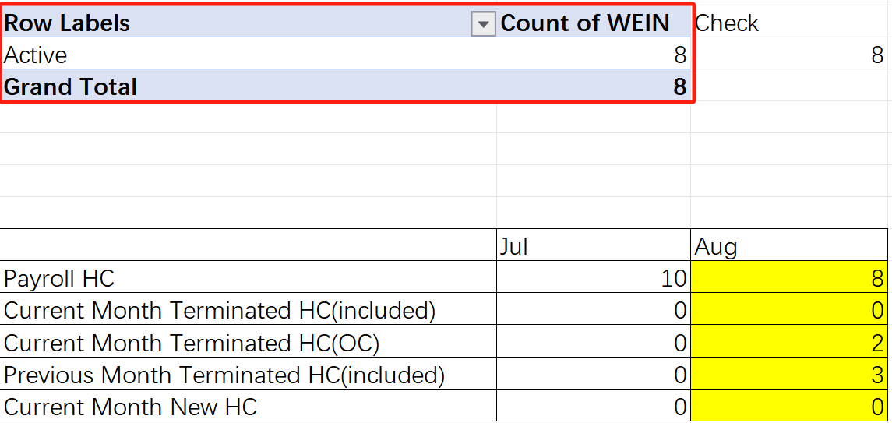

Extract the full set of WEIN from the previous month's 【Payroll Report】 where [Hire Status = Active], calculate the count of WEIN, and write the corresponding value into the designated row and column for the previous month (indicated by the red cell in the diagram).

Extract the full set of WEIN from the current month's 【Payroll Report】 where [Hire Status = Active], calculate the count of WEIN, and write the corresponding value into the designated row and column for the current month (indicated by the green cell in the diagram).

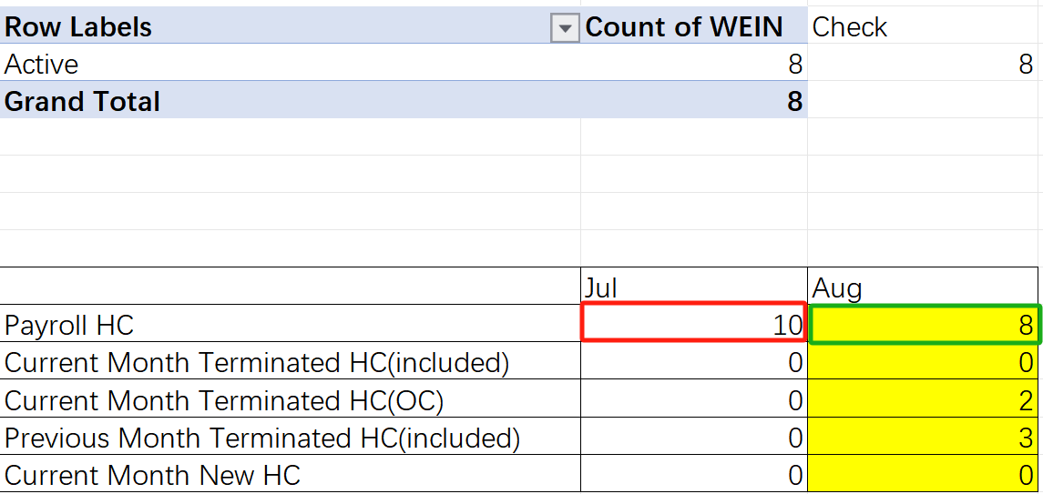

Extract the full set of Employee Code and Termination Date from the previous month's 【1263 ADP flexiform template_HK_Termination】 table.

If [Termination Date + 7] falls after the pay day, categorize it as Current Month Terminated HC (included).

If [Termination Date + 7] falls before the pay day, categorize it as Current Month Terminated HC (OC).

Calculate the respective counts for Current Month Terminated HC (included) and Current Month Terminated HC (OC), and write the corresponding values into the designated rows and columns for the previous month.

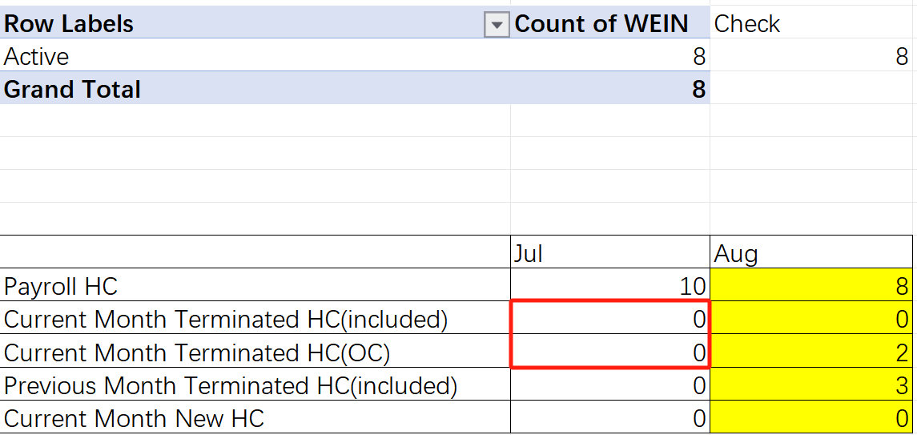

Extract the full set of Employee Code and Termination Date from the current month's 【1263 ADP flexiform template_HK_Termination】 table.

If [Termination Date + 7] falls after the pay day, categorize it as Current Month Terminated HC (included).

If [Termination Date + 7] falls before the pay day, categorize it as Current Month Terminated HC (OC).

Calculate the respective counts for Current Month Terminated HC (included) and Current Month Terminated HC (OC), and write the corresponding values into the designated rows and columns for the current month.
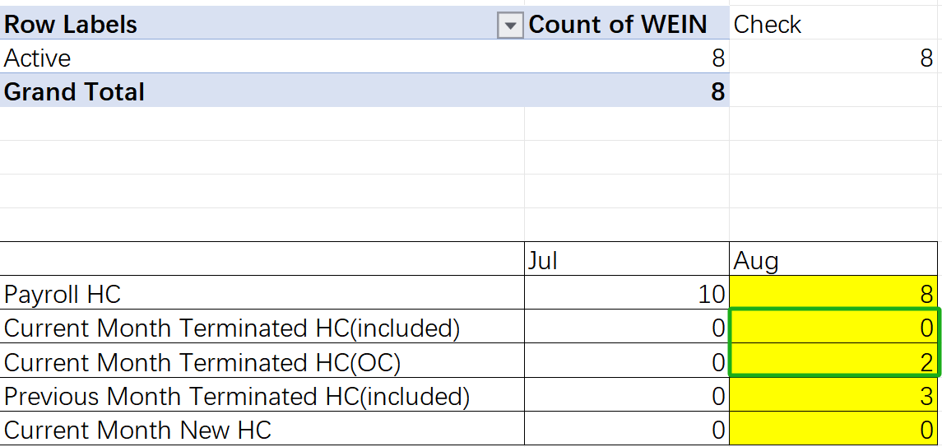

Extract the full set of WEIN from the [Previous Month Terminated HC] sheet of the【额外表】for the previous month, calculate the count of WEIN, and write the corresponding value into the designated row and column for the previous month (indicated by the red cell in the diagram).

Extract the full set of WEIN from the [Previous Month Terminated HC] sheet of the 【额外表】for the current month, calculate the count of WEIN, and write the corresponding value into the designated row and column for the current month (indicated by the green cell in the diagram).

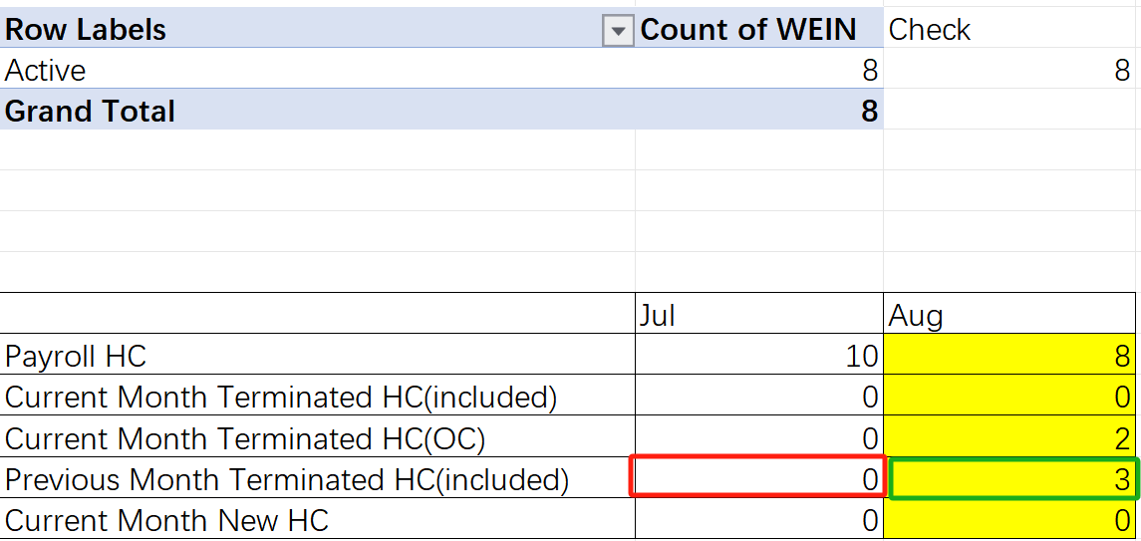

Extract the full set of Employee ID from the previous month's 【1263 ADP flexiform template_HK_NewHire】 table, calculate the count of Employee ID, and write the corresponding value into the designated row and column for the previous month (indicated by the red cell in the diagram).

Extract the full set of Employee ID from the current month's 【1263 ADP flexiform template_HK_NewHire】 table, calculate the count of Employee ID, and write the corresponding value into the designated row and column for the current month (indicated by the green cell in the diagram).

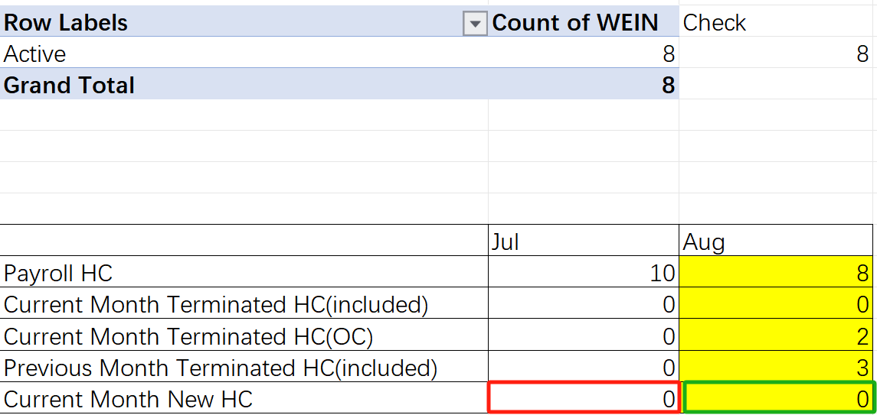

Create a Check column to the right of the PivotTable and calculate the value of <Last Month's Payroll HC - Last Month's Current Month Terminated HC (included) - Current Month's Current Month Terminated HC (OC) + Current Month's Current Month New HC>. Place the calculation result in the Check column.

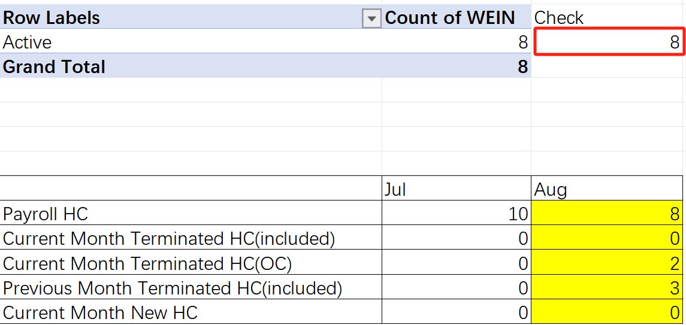

Master Data Check
- Legal Full Name
Sequentially extract the Legal Last Name and Legal First Name corresponding to all WEINs from the Check Result sheet of the 【HK Payroll Validation Output YYYYMMDD】 table. Insert Legal Full Name, Check, and Diff columns to the right of the Legal First Name column. Finally, populate the corresponding rows and columns with values according to the logic defined in the table.

Check Result | Check Result
Legal First Name&" "&Legal Last Name | Legal full name

Extract the full set of Employee ID and Legal Full Name from the 【Workforce Detail - Payroll-AP】 table. Map the Employee ID to the WEIN in the Check Result sheet and write the corresponding values into their designated rows and columns.

Workforce Detail - Payroll-AP | Check Result
Legal Full Name | Legal full name Check

- Last Hired Date
Extract the full set of Employee ID and Last Hire Date from the 【Workforce Detail - Payroll-AP】 table. Map the Employee ID to the WEIN in the Check Result sheet and write the corresponding values into their designated rows and columns.

Workforce Detail - Payroll-AP | Check Result
Last Hire Date | Last Hired Date Check

- Last Employment Date
Extract the full set of Employee ID and Termination Date from the 【1263 ADP flexiform template_HK_Termination】 table. Map the Employee ID to the WEIN in the Check Result sheet and write the corresponding values into their designated rows and columns.

1263 ADP flexiform template_HK_Termination | Check Result
Termination Date | Last Employment Date Check

- Business Department
Extract the full set of Employee ID and Business Department from the 【Workforce Detail - Payroll-AP】 table. Map the Employee ID to the WEIN in the Check Result sheet and write the corresponding values into their designated rows and columns.

Workforce Detail - Payroll-AP | Check Result
Business Department | Business Department Check

- Position Title
Extract the full set of Employee ID and Position Title from the 【Workforce Detail - Payroll-AP】 table. Map the Employee ID to the WEIN in the Check Result sheet and write the corresponding values into their designated rows and columns.

Workforce Detail - Payroll-AP | Check Result
Position Title | Position Title Check

- Cost Center Code
Extract the full set of Employee ID and Cost Center - ID from the 【Workforce Detail - Payroll-AP】 table. Map the Employee ID to the WEIN in the Check Result sheet and write the corresponding values into their designated rows and columns.

Workforce Detail - Payroll-AP | Check Result
Cost Center - ID | Cost Center Code Check

- Monthly Base Pay / Monthly Base Pay(Temp)
Extract the full set of Employee ID and Monthly Salary from the 【Workforce Detail - Payroll-AP】 table for data where [Employee Type = Regular] and [Employee Type = Intern/Co-ops] respectively. Map the Employee ID to the WEIN in the Check Result sheet and write the corresponding values into their designated rows and columns. (The Monthly Salary values should be rounded to the nearest integer.)

(Note: For all subsequent fields involving Monthly Salary, whether for direct output or calculations, the values must first be rounded to the nearest integer before any further operations.)

Workforce Detail - Payroll-AP | Check Result
Monthly Salary[Employee Type=Regular] | Monthly Base Pay Check
Monthly Salary[Employee Type= Intern/Co-ops] | Monthly Base Pay(Temp) Check

- Monthly Transport Allowance
Extract the full set of Employee ID and Amount from the 【Allowance plan report】 table where [Compensation Plan = Transportation Allowance]. Map the Employee ID to the WEIN in the Check Result sheet and write the corresponding values into their designated rows and columns.

Allowance plan report | Check Result
Amount[Compensation Plan= Transportation Allowance] | Monthly Transport Allowance Check

Pay Items
- Base Pay / Base Pay(Temp)
Extract the full set of Employee ID, Last Hire Date, and Monthly Salary (rounded to the nearest integer) from the 【Workforce Detail - Payroll-AP】 table. Apply the following calculation logic to derive the Base Pay and Base Pay (Temp) results (rounded to two decimal places)
(Note: For all subsequent calculation results, round to two decimal places.)
- Calculation logic as per the table below:
Base Pay | Actual working day * Monthly Salary
Base Pay(Temp) | Actual working day * Monthly Salary

Map the Employee ID to the WEIN in the Check Result sheet and write the corresponding values into their designated rows and columns.

Workforce Detail - Payroll-AP | Check Result
Base Pay | Base Pay 60001000 Check
Base Pay(Temp) | Base Pay(Temp) 60101000 Check

- Salary Adj / Transport Allowance Adj
Extract the full set of WIN, FROM DATE, TO DATE, APPLY DATE, and APPROVAL DATE from the 【Employee_Leave_Transactions_Report】 table where [STATUS = Approved]. Use the combination of WIN & FROM DATE & TO DATE & APPLY DATE & APPROVAL DATE as a unique identifier to compare with the previous month's data and identify new (i.e., unpaid) leave records. Apply the following calculation logic to the newly identified leave records:

- Maternity Leave
Extract the full set of WIN, FROM DATE, TO DATE, and TOTAL DAYS from the newly identified (i.e., unpaid) leave records where [LEAVE TYPE = Maternity Leave], and convert the TOTAL DAYS values to a numeric format. If the FROM DATE and TO DATE span across multiple calendar months, split the record by calendar month into multiple entries, with each entry containing only the actual number of days falling within a single calendar month.

Map the WIN to the Employee ID in the 【Workforce Detail - Payroll-AP】 table and retrieve the Last Hire Date. Determine the employee's length of service based on the Last Hire Date.

If the employee has worked at MSD for less than 40 weeks before the start of maternity leave, exclude this TOTAL DAYS record.

If the employee has worked at MSD for 40 weeks or more before the start of maternity leave, adhere to the principle that "the current month's payroll settles leave from the previous month". Extract the TOTAL DAYS falling within the current month's payroll scope and record it as "Maternity Leave TOTAL DAYS".

Leave days that do not fall within the current month's payroll scope (i.e., unsettled days) should be carried over to the next month for processing. During each monthly payroll run, check for any remaining unsettled leave days from the previous month that need to be processed in the current month.

- Paternity Leave
Extract the full set of WIN, FROM DATE, TO DATE, and TOTAL DAYS from the newly identified (i.e., unpaid) leave records where [LEAVE TYPE = Paternity Leave], and convert the TOTAL DAYS values to a numeric format. If the FROM DATE and TO DATE span across multiple calendar months, automatically split the record into multiple entries, with each entry containing only the actual number of days falling within a single calendar month.

Adhere to the principle that "the current month's payroll settles leave from the previous month". Process the split leave data and extract the TOTAL DAYS falling within the current month's payroll scope, recording it as "Paternity Leave TOTAL DAYS".

Leave days that do not fall within the current month's payroll scope (i.e., unsettled days) should be carried over to the next month for processing. During each monthly payroll run, check for any remaining unsettled leave from the previous month that needs to be processed in the current month.

Calculate the value as:
Maternity Leave TOTAL DAYS + Paternity Leave TOTAL DAYS
and record it as "Leave Days".

Map the WIN to the Employee ID in the 【Workforce Detail - Payroll-AP】 table and retrieve the corresponding Monthly Salary (rounded to the nearest integer).

Apply the following calculation logic to derive the Salary Adj result (rounded to two decimal places). Map the result to the WEIN in the Check Result sheet and write the corresponding value into its designated row and column.

Employee_Leave_Transactions_Report | Check Result
- Monthly Salary/calendar days LastMonth* leave days | Salary Adj 60001000 Check
- Monthly Salary/calendar days LastMonth* leave days | Transport Allowance Adj 60409960 Check

- Transport Allowance
Extract the full set of WIN, FROM DATE, TO DATE, APPLY DATE, and APPROVAL DATE from the 【Employee_Leave_Transactions_Report】 table where [STATUS = Approved]. Use the combination of WIN & FROM DATE & TO DATE & APPLY DATE & APPROVAL DATE as a unique identifier to compare with the previous month's data and identify new (i.e., unpaid) leave records.

From the newly identified unpaid leave records, extract the full set of WIN, FROM DATE, TO DATE, and TOTAL DAYS where [LEAVE TYPE = Unpaid Leave], and convert the TOTAL DAYS values to a numeric format. If the FROM DATE and TO DATE span across multiple calendar months, automatically split the record into multiple entries, with each entry containing only the actual number of days falling within a single calendar month.

Extract the TOTAL DAYS value for the current month and record it as "No pay leave days".

Map the WIN to the Employee ID in the 【Allowance plan report】 table and retrieve the corresponding Amount where [Compensation Plan = Transportation Allowance]. Apply the following calculation logic to derive the Transport Allowance result (rounded to two decimal places). Map the Employee ID to the WEIN in the Check Result sheet and write the corresponding value into its designated row and column.

Employee_Leave_Transactions_Repor/Allowance plan report | Check Result
Amount- Amount / calendar days CurrentMonth *No pay leave days | Transport Allowance 60409960 Check

- Total EAO Adj
Extract the full set of WEIN, AverageDayWage_12Month, DailySalary, Days_AnnualLeave_LastMonth, Days_AnnualLeave, and Days_StatutoryHolidays from the 【EAO Summary Report_YYYYMM】 table.

For each WEIN, calculate the value as:
Days_AnnualLeave_LastMonth + Days_AnnualLeave + Days_StatutoryHolidays
and record it as "days".

Calculate the result according to the logic specified in the table, then map the result to the WEIN in the Check Result sheet and write the corresponding value into its designated row and column.

EAO Summary Report_YYYYMM | Check Result
（AverageDayWage_12Month-DailySalary）* days | Total EAO Adj 60409960 Check

- Maternity Leave Payment
Extract the full set of WIN and FROM DATE from the 【Employee_Leave_Transactions_Report】 table where [STATUS = Approved] and [LEAVE TYPE = Maternity Leave].

For each WIN, retrieve the DayWage_Maternity/Paternity/Sick Leave and Days_MaternityLeave from the 【EAO Summary Report_YYYYMM】 table corresponding to the month of the FROM DATE. Calculate the result according to the logic specified in the table, then map the result to the WEIN in the Check Result sheet and write the corresponding value into its designated row and column.

EAO Summary Report_YYYYMM | Check Result
DayWage_Maternity/Paternity/Sick Leave* Days_MaterintyLeave | Maternity Leave Payment 60001000 Check

- Sick leave payment
Extract the full set of WIN and FROM DATE from the 【Employee_Leave_Transactions_Report】 table where [STATUS = Approved] and [LEAVE TYPE = Sick Leave].

For each WIN, retrieve the DayWage_Maternity/Paternity/Sick Leave and Days_SickLeave from the 【EAO Summary Report_YYYYMM】 table corresponding to the month of the FROM DATE. Calculate the result according to the logic specified in the table, then map the result to the WEIN in the Check Result sheet and write the corresponding value into its designated row and column.

EAO Summary Report_YYYYMM | Check Result
DayWage_Maternity/Paternity/Sick Leave* Days_SickLeave | Sick Leave Payment 60001000 Check

- Paid Parental Time Off (PPTO) payment
Extract the full set of WIN and FROM DATE from the 【Employee_Leave_Transactions_Report】 table where [STATUS = Approved] and [LEAVE TYPE = Paid Parental Time Off (PPTO)].

For each WIN, retrieve the DailySalary, AverageDayWage_12Month, and Days_Paid Parental Time Off from the 【EAO Summary Report_YYYYMM】 table corresponding to the month of the FROM DATE. Calculate the value as:
Max(DailySalary, AverageDayWage_12Month × 80%) × Days_Paid Parental Time Off
and record it as "Paid Parental Time Off (PPTO) payment".

Map the WEIN to the WEIN in the Check Result sheet and write the calculated value into its designated row and column.

EAO Summary Report_YYYYMM | Check Result
Paid Parental Time Off (PPTO) payment | Paid Parental Time Off (PPTO) payment Check

- No Pay Leave Deduction
Extract the full set of WEIN, NoPayLeaveCalculationBase, Days_NoPayLeave, and Days_NoPayLeave_LastMonth from the 【EAO Summary Report_YYYYMM】 table. Calculate the result according to the logic specified in the table, then map the result to the WEIN in the Check Result sheet and write the corresponding value into its designated row and column.

EAO Summary Report_YYYYMM | Check Result
NoPayLeaveCalculationBase*（Days_NoPayLeave+Days_NoPayLeave_LastMonth） | No Pay Leave Deduction 60001000 Check

- Untaken Annual Leave Payment
Extract the full set of WEIN, AverageDayWage_12Month, and Untaken Annual Leave Days from the 【EAO Summary Report_YYYYMM】 table. Map the WEIN to the Employee ID in the 【Workforce Detail - Payroll-AP】 table and extract the full set of Employee ID and Monthly Salary (rounded to the nearest integer).

For each WEIN, calculate the value as:
MAX(Monthly Salary / 22, AverageDayWage_12Month) × Untaken Annual Leave Days
and record it as "Untaken Annual Leave Payment".
Map the WEIN to the WEIN in the Check Result sheet and write the calculated value into its designated row and column.
EAO Summary Report_YYYYMM/ Workforce Detail - Payroll-AP | Check Result
Untaken Annual Leave Payment | Untaken Annual Leave Payment 60409960 Check

- Annual Incentive
Extract the Employee ID and Actual Payment – Amount values from the 【One time payment report】 table where [One-Time Payment Plan = AIP]. If duplicate Employee IDs are found, sum their Actual Payment – Amount values to ensure each Employee ID receives only one consolidated Actual Payment – Amount value.

Map the Employee ID to the WEIN in the Check Result sheet and write the corresponding Actual Payment – Amount value into its designated row and column.

One time payment report | Check Result
Actual Payment – Amount [One-Time Payment Plan = AIP] | Annual Incentive 60201000 Check

- Sales Incentive (Quantitative)
Extract the full set of Employee ID and TOTAL PAYOUT values from the 【2025QX Payout Summary】 table where [Pay Item = Sales Incentive Plan]. Map the Employee ID to the WEIN in the Check Result sheet and write the corresponding value into its designated row and column.

2025QX Payout Summary | Check Result
TOTAL PAYOUT[Pay Item=Sales Incentive Plan] | Sales Incentive (Quantitative) 21201000 Check

- Sales Incentive (Qualitative)
Extract the full set of Employee ID and TOTAL PAYOUT values from the 【2025QX Payout Summary】 table where [Pay Item = Qualitative Incentive Plan]. Map the Employee ID to the WEIN in the Check Result sheet and write the corresponding value into its designated row and column.

2025QX Payout Summary | Check Result
TOTAL PAYOUT[Pay Item=Qualitative Incentive Plan] | Sales Incentive (Qualitative) 21201000 Check

- Inspire Cash
Extract the full set of Employee ID and Actual Payment – Amount values from the 【Inspire Awards Payroll Report】 table where [One-Time Payment Plan = Inspire Cash]. If duplicate Employee IDs are found, sum their Actual Payment – Amount values to ensure each Employee ID receives only one consolidated Actual Payment – Amount value.

Map the Employee ID to the WEIN in the Check Result sheet and write the corresponding value into its designated row and column.

Inspire Awards Payroll Report | Check Result
Actual Payment – Amount | Inspire Cash 60702000 Check

- Inspire Point
Extract the full set of Employee ID and Actual Payment – Amount values from the 【Inspire Awards Payroll Report】 table where [One-Time Payment Plan = Inspire Points Value]. If duplicate Employee IDs are found, sum their Actual Payment – Amount values to ensure each Employee ID receives only one consolidated Actual Payment – Amount value.

Map the Employee ID to the WEIN in the Check Result sheet and write the corresponding value into its designated row and column.

Inspire Awards Payroll Report | Check Result
Actual Payment – Amount | Inspire Points Check

- Shares Dividend
- Determine whether the current month is May. If not, skip this step. If yes, extract the full set of Employee Reference and Gross Award Amount to be Paid from the 【RSU Dividend global report】 table, and retrieve the Exchange rate from the 【config】 table.

For each Employee Reference, calculate the value as:
Gross Award Amount to be Paid × Exchange rate
If duplicate Employee References are found, sum the calculated values to ensure each Employee Reference receives only one consolidated value.

Map the Employee Reference to the WEIN in the Check Result sheet and write the corresponding calculated value into its designated row and column.

RSU Dividend global report | Check Result
Gross Award Amount to be Paid * Exchange rate | Shares Dividend Check

- Determine whether the current month is June. If not, skip this step. If yes, extract the full set of EmployeeNumber and Dividend To Pay from the 【RSU Dividend EY report】 table, and retrieve the Exchange rate from the 【config】 table.

For each Employee Number, calculate the value as:
Dividend To Pay × Exchange rate
If duplicate Employee Numbers are found, sum the calculated values to ensure each Employee Number receives only one consolidated value.

Map the Employee Number to the WEIN in the Check Result sheet and write the corresponding calculated value into its designated row and column.

RSU Dividend EY report | Check Result
Gross Award Amount to be Paid * Exchange rate | Shares Dividend Check

- Red Packet
Extract the Employee ID and Actual Payment – Amount values from the 【One time payment report】 table where [One-Time Payment Plan = Red Packet]. If duplicate Employee IDs are found, sum their Actual Payment – Amount values to ensure each Employee ID receives only one consolidated Actual Payment – Amount value.

Map the Employee ID to the WEIN in the Check Result sheet and write the corresponding Actual Payment – Amount value into its designated row and column.

One time payment report | Check Result
Actual Payment – Amount | Red Packet 69001000 Check

- Year End Bonus
Extract the full set of Employee Code from the current month's 【1263 ADP flexiform template_HK_Termination】 table. Map the Employee Code to the Employee ID in the 【Workforce Detail - Payroll-AP】 table, retrieve the corresponding Monthly Salary (rounded to the nearest integer), and write the value into its designated row and column.

1263 ADP flexiform template_HK_Termination/ Workforce Detail - Payroll-AP | Check Result
Monthly Salary | Year End Bonus 60208000 Check

Determine whether the current month is December. If not, skip this step. If yes, extract the Employee ID, Last Hire Date, and Monthly Salary (rounded to the nearest integer) from the 【Workforce Detail - Payroll-AP】 table. Map the Employee ID to the WEIN in the Check Result sheet and write the corresponding values into their designated rows and columns.

If the employee has worked for less than one full year in the current year:

Workforce Detail - Payroll-AP | Check Result
Monthly Salary/ Annual Period * Service Period | Year End Bonus 60208000 Check

If the employee has worked for a full year or more:
Workforce Detail - Payroll-AP | Check Result
Monthly Salary | Year End Bonus 60208000 Check

- Lump Sum Bonus
Extract the Employee ID and Actual Payment – Amount values from the 【One time payment report】 table where [One-Time Payment Plan = Lump Sum Bonus]. If duplicate Employee IDs are found, sum their Actual Payment – Amount values to ensure each Employee ID receives only one consolidated Actual Payment – Amount value.

Map the Employee ID to the WEIN in the Check Result sheet and write the corresponding Actual Payment – Amount value into its designated row and column.

One time payment repor | Check Result
Actual Payment – Amount  [One-Time Payment Plan = Lump Sum Bonus] | Lump Sum Bonus 60409960 Check

- Referral Bonus
Extract the Employee ID and Actual Payment – Amount values from the 【One time payment report】 table where [One-Time Payment Plan = Referral Bonus]. If duplicate Employee IDs are found, sum their Actual Payment – Amount values to ensure each Employee ID receives only one consolidated Actual Payment – Amount value.

Map the Employee ID to the WEIN in the Check Result sheet and write the corresponding Actual Payment – Amount value into its designated row and column.

One time payment report | Check Result
Actual Payment – Amount  [One-Time Payment Plan = Referral Bonus] | Referral Bonus 69001000 Check

- Sign On Bonus
Extract the Employee ID and Actual Payment – Amount values from the 【One time payment report】 table where [One-Time Payment Plan = Sign On Bonus]. If duplicate Employee IDs are found, sum their Actual Payment – Amount values to ensure each Employee ID receives only one consolidated Actual Payment – Amount value.

Map the Employee ID to the WEIN in the Check Result sheet and write the corresponding Actual Payment – Amount value into its designated row and column.

One time payment report | Check Result
Actual Payment – Amount  [One-Time Payment Plan = Sign On Bonus] | Sign On Bonus 60409960 Check

- Retention Bonus
Extract the Employee ID and Actual Payment – Amount values from the 【One time payment report】 table where [One-Time Payment Plan = Retention Bonus]. If duplicate Employee IDs are found, sum their Actual Payment – Amount values to ensure each Employee ID receives only one consolidated Actual Payment – Amount value.

Map the Employee ID to the WEIN in the Check Result sheet and write the corresponding Actual Payment – Amount value into its designated row and column.

One time payment repor | Check Result
Actual Payment – Amount | Retention Bonus 60409960 Check

- Flexible benefits
Extract the full set of WEIN and Flexible benefits from the [特殊奖金]sheet of the 【额外表】.

Map the WEIN to the WEIN in the Check Result sheet and write the corresponding Flexible benefits values into their designated rows and columns.

额外表 | Check Result
Flexible benefits | Flexible benefits Check
- Manager of the Year Award
Extract the Employee ID and Actual Payment – Amount values from the 【One time payment report】 table where [One-Time Payment Plan = Manager of the Year Award]. If duplicate Employee IDs are found, sum their Actual Payment – Amount values to ensure each Employee ID receives only one consolidated Actual Payment – Amount value.

Map the Employee ID to the WEIN in the Check Result sheet and write the corresponding Actual Payment – Amount value into its designated row and column.

One time payment repor | Check Result
Actual Payment – Amount | Manager of the Year Award 60208000 Check

- MD Award
Extract the Employee ID and Actual Payment – Amount values from the 【One time payment report】 table where [One-Time Payment Plan = MD Award]. If duplicate Employee IDs are found, sum their Actual Payment – Amount values to ensure each Employee ID receives only one consolidated Actual Payment – Amount value.

Map the Employee ID to the WEIN in the Check Result sheet and write the corresponding Actual Payment – Amount value into its designated row and column.

One time payment repor | Check Result
Actual Payment – Amount | MD Award 60208000 Check

- Other Allowance
Extract the full set of WEIN and Other Allowance from the [特殊奖金] sheet of the 【额外表】.
Map the WEIN to the WEIN in the Check Result sheet and write the corresponding Other Allowance values into their designated rows and columns.

额外表 | Check Result
Other Allowance | Other Allowance 60409960 Check

- Other Bonus
Extract the full set of WEIN and Other Bonus from the [特殊奖金] sheet of the 【额外表】.
Map the WEIN to the WEIN in the Check Result sheet and write the corresponding Other Bonus values into their designated rows and columns.
额外表 | Check Result
Other Bonus | Other Bonus 99999999 Check

- Other Rewards
Extract the full set of WEIN and Other Rewards from the [特殊奖金] sheet of the 【额外表】.
Map the WEIN to the WEIN in the Check Result sheet and write the corresponding Other Rewards values into their designated rows and columns.
额外表 | Check Result
Other Rewards | Other Rewards 99999999 Check
- IA Pay Split
Extract the full set of Employee ID, Net Pay (include EAO & leave payment), MPF Relevant Income, MPF VC Relevant Income, MPF EE MC, and MPF EE VC from the respective 【Merck Payroll Summary Report——xxx】 tables (where "xxx" represents the employee's name) for each different employee.

For each Employee ID, calculate the value as:
Net Pay (include EAO & leave payment) + MPF EE MC + MPF EE VC
and record it as "IA Pay Split".

Map the Employee ID to the WEIN in the Check Result sheet and write the corresponding IA Pay Split value into its designated row and column.

Merck Payroll Summary Report——xxx | Check Result
IA Pay Split | IA Pay Split Check

- Severance Payment / Long Service Payment
Map the WEIN to the Employee Code in the 【1263 ADP flexiform template_HK_Termination】 table and retrieve the corresponding Termination Date.
Map the WEIN to the Employee ID in the 【Workforce Detail - Payroll-AP】 table and retrieve the corresponding Last Hire Date and Monthly Salary (rounded to the nearest integer).
Extract the full set of WEIN, MSD policy or Statutory Policy, and Termination Type from the [Final payment] sheet of the【额外表】.

Calculate the employee's Years of Service (YOS) using the formula:
YOS = Termination Date – Last Hire Date
If the years of service are not a whole number, round the result to two decimal places.
Example: An employee with a Last Hire Date of 2022/01/01 and a Termination Date of 2025/06/30 would have a YOS of 3.50.

Based on the Years of Service and Termination Type, determine whether the employee is eligible for Severance Payment or Long Service Payment (this logic is maintained in the [Final payment] sheet of the 【config】 table):
- If the Termination Type is classified as redundancy, or if YOS < 5, the employee is eligible for Severance Payment. Determine the calculation formula based on MSD policy or Statutory Policy as specified in the table below, and write the calculation result into the corresponding row and column.
额外表/ 1263 ADP flexiform template_HK_Termination | Check Result
Base Pay*Min(24, YOS）（MSD policy or Statutory Policy= MSD policy） | Severance Payment 60404000 Check
Min(Min(Monthly Salary * 2/3, 22500*2/3=15000)*YOS, 390,000)（MSD policy or Statutory Policy= Statutory Policy） | Severance Payment 60404000 Check

- If the Termination Type is not redundancy and YOS ≥ 5, calculate the Long Service Payment for the employee. Determine the calculation formula based on the MSD policy or Statutory Policy as shown in the table below, and write the calculation result into the corresponding row and column.
额外表/1263 ADP flexiform template_HK_Termination | Check Result
Base Pay*Min(24, YOS）（MSD policy or Statutory Policy= MSD policy） | Long Service Payment 60409960 Check
Min(Min(Monthly Salary * 2/3, 22500*2/3=15000)*YOS, 390,000)（MSD policy or Statutory Policy= Statutory Policy） | Long Service Payment 60409960 Check

- Payment in lieu of notice (ER to EE/EE to ER)
Extract the full set of WEIN, PIL Indicator, Notice Given Date, and Notice Period from the [Final payment] sheet of the 【额外表】.

For each WEIN:

Retrieve the corresponding Last Hire Date Check, Monthly Base Pay Check, and Monthly Base Pay (Temp) Check from the [Check Result] sheet of the 【HK Payroll Validation Output YYYYMMDD.xlsx】 table.

Map the WEIN to the Employee ID in the 【Allowance plan report】 table and extract the Amount where [Compensation Plan = Transportation Allowance].

Retrieve the corresponding TotalWage_12Month from the 【EAO Summary Report_YYYYMM】 table.

Map the WEIN to the Employee Code in the 【1263 ADP flexiform template_HK_Termination】 table and extract the Termination Date.

Apply the calculation logic specified in the table. Based on the WEIN mapping to the WEIN in the Check Result sheet and the PIL Indicator, write the corresponding values into their designated rows and columns.

额外表/ Workforce Detail - Payroll-AP/ Allowance plan report | Check Result
PIL EE to ER Days*Min((Monthly Base Pay Check+Monthly Base Pay(Temp) Check + Amount)/Notice Days, TotalWage_12Month/12/NoticeDays or TotalWage_12Months/servie day (if YOS<1 or Notice Period=14 days, Service Days= No. of days from Hire Date to the end date of the previous month of Notice Given Date))  （PIL Indicator= EE to ER） | PIL EE to ER 60001000 Check
PIL ER to EE Days*Max((Monthly Base Pay Check+Monthly Base Pay(Temp) Check + Amount)/Notice Days, TotalWage_12Month/12/NoticeDays or TotalWage_12Months/servie day (if YOS<1 or Notice Period=14 days, Service Days= No. of days from Hire Date to the end date of the previous month of Notice Given Date))  （PIL Indicator= ER to EE） | PIL ER to EE 60001000 Check
Where: NoticeDays = Notice Period, PIL EE to ER Days = NoticeDays − (Termination Date − Notice Given Date), PIL ER to EE Days = NoticeDays − (Termination Date − Notice Given Date).

- Gratuities
Extract the full set of WEIN and Gratuities from the [Final payment] sheet of the【额外表】.
Map the WEIN to the WEIN in the Check Result sheet and write the corresponding Gratuities values into their designated rows and columns.

额外表 | Check Result
Gratuities | Gratuities 99999999 Check

- Optional Group Upgrade
Extract the full set of WEIN and Optional Group Upgrade 21351000 from the 【Optional medical plan enrollment form】 table.
Map the WEIN to the WEIN in the Check Result sheet and write the corresponding Optional Group Upgrade 21351000 values into their designated rows and columns.

Optional medical plan enrollment form | Check Result
Optional Group Upgrade 21351000 | Optional Group Upgrade 21351000 Check

- Back Pay
Extract the full set of WEIN and Back Pay from the [Final payment] sheet of the 【额外表】.
Map the WEIN to the WEIN in the Check Result sheet and write the corresponding Back Pay values into their designated rows and columns.

额外表 | Check Result
Back Pay | Back Pay 99999999 Check

Contribution
- MPF Relevant Income
Extract the specified values for each WEIN from the 【Payroll Report】 table, as listed in the table below. Retrieve the corresponding Goods & Services Differential from the [特殊奖金] sheet of the 【额外表】 based on the WEIN.
Calculate the result according to the logic specified in the table, then map the result to the WEIN in the Check Result sheet and write the corresponding value into its.

Payroll Report/额外表 | Check Result
Goods & Services Differential  + Gratuity Bonus 60208000  + Lump Sum Bonus 60409960  +Sign On Bonus 60409960  +Retention Bonus 60409960  + Referral Bonus 69001000  + Annual Incentive 60201000  + Sales Incentive (Quantitative) 21201000  + Sales Incentive (Qualitative) 21201000  + AP President Club 60208000  + Manager of the Year Award 60208000  + MD Award 60208000  + Employee Award 60208000  + Inspire Points (Gross Up) 60701000  + Inspire Cash 60702000  + Year End Bonus 60208000  + Shares Dividend 60204001  + Red Packet 69001000  + Other Allowance 60409960  + Other Bonus 99999999  + Other Rewards 99999999  + Education Benefits 99999999  + Pensions 99999999  + Maternity Leave Payment 60001000  + Paternity Leave Payment 60001000  + Sick Leave Payment 60001000  + Salary Adj 60001000  + Salary Adj (Temp) 60101000  + Transport Allowance Adj 60409960  + Housing Allowance Adj 60409960  + Rental Reimbursement Adj 60001000  + Total EAO Adj 60409960  + No Pay Leave Deduction 60001000  + Overtime Payment 99999999  + Base Pay 60001000  + Base Pay(Temp) 60101000  + Housing Allowance 60409960  + Transport Allowance 60409960  + Rental Reimbursement 60001000 | MPF Relevant Income Check

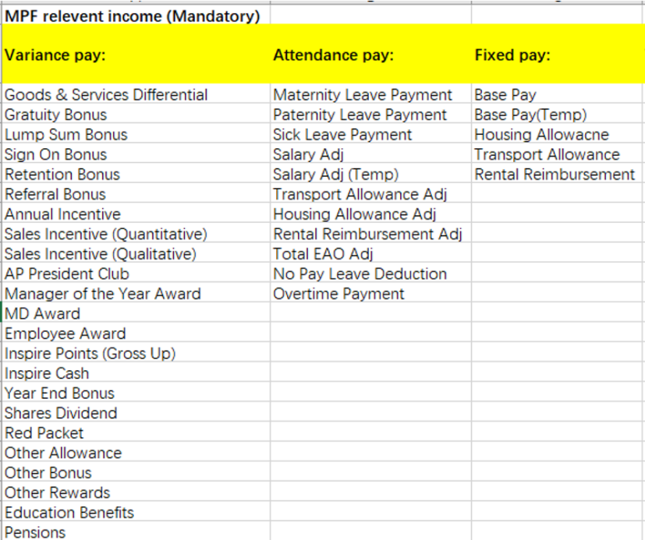
- MPF VC Relevant Income
Extract the specified values for each WEIN from the 【Payroll Report】 table, as listed in the table below. Calculate the result according to the logic specified in the table, then map the result to the WEIN in the Check Result sheet and write the corresponding value into its designated row and column.

Payroll Report | Check Result
Base Pay 60001000  + Base Pay(Temp) 60101000  + Rental Reimbursement  + Total EAO Adj 60409960  + Salary Adj 60001000  + Salary Adj (Temp) 60101000  + Rental Reimbursement Adjustment  + Maternity Leave Payment 60001000 Check  + Paternity Leave Payment 60001000  +Paid Parental Time Off (PPTO) payment  +Sick Leave Payment 60001000  -No Pay Leave Deduction 60001000 | MPF VC Relevant Income Check

- MPF EE MC
Extract the full set of WEIN and MPF Relevant Income Check from the Check Result sheet of the 【HK Payroll Validation Output YYYYMMDD】 table. Map the WEIN to the WEIN in the Check Result sheet and write the corresponding values into their designated rows and columns.

HK Payroll Validation Output YYYYMMDD | Check Result
MIN(MPF Relevant Income Check*5%,1500) | MPF EE MC 21251000 Check

- MPF EE VC
Extract the full set of WEIN and MPF VC Relevant Income Check from the Check Result sheet of the 【HK Payroll Validation Output YYYYMMDD】 table, and retrieve the corresponding MPF EE VC Percentage from the [MPF&ORSO] sheet of the 【额外表】 based on the WEIN.

Map the WEIN to the WEIN in the Check Result sheet and write the corresponding values into their designated rows and columns.

HK Payroll Validation Output YYYYMMDD/额外表 | Check Result
MPF VC Relevant Income Check *MPF EE VC Percentage | MPF EE VC 21251000 Check
MPF EE VC Percentage | MPF EE VC Percentage Check

- MPF ER MC
Extract the full set of WEIN and MPF Relevant Income Check from the Check Result sheet of the 【HK Payroll Validation Output YYYYMMDD】 table. Map the WEIN to the WEIN in the Check Result sheet and write the corresponding values into their designated rows and columns.

HK Payroll Validation Output YYYYMMDD | Check Result
MIN(MPF Relevant Income Check*5%,1500) | MPF ER MC 60801000 Check
- MPF ER VC
Extract the full set of WEIN, MPF VC Relevant Income Check, and MPF ER MC 60801000 Check from the Check Result sheet of the 【HK Payroll Validation Output YYYYMMDD】 table. Retrieve the corresponding MPF ER VC Percentage from the [MPF&ORSO] sheet of the 【额外表】 based on the WEIN.

- Calculate the result as follows:
MPF VC Relevant Income Check × MPF ER VC Percentage − MPF ER MC 60801000 Check
If the result is less than 0, no further processing is required. If the result is greater than 0, calculate:
ROUND(MPF VC Relevant Income Check × MPF ER VC Percentage, 2) − MPF ER MC 60801000 Check
and record it as "MPF ER VC".

Map the WEIN to the WEIN in the Check Result sheet and write the corresponding value into its designated row and column.

HK Payroll Validation Output YYYYMMDD/额外表 | Check Result
MPF ER VC | MPF ER VC 60801000 Check
MPF ER VC Percentage | MPF ER VC Percentage Check

- ORSO Relevant Income
Extract the full set of Employee ID and Monthly Salary (rounded to the nearest integer) from the 【Workforce Detail - Payroll-AP】 table. Map the Employee ID to the WEIN in the Check Result sheet and write the corresponding values into their designated rows and columns.

Workforce Detail - Payroll-AP | Check Result
Monthly Salary | ORSO Relevant Income Check

- ORSO EE
Extract the full set of WEIN and ORSO Relevant Income Check from the Check Result sheet of the 【HK Payroll Validation Output YYYYMMDD】 table. Finally, calculate the result according to the logic specified in the table, map the result to the WEIN in the Check Result sheet, and write the corresponding value into its designated row and column.

HK Payroll Validation Output YYYYMMDD | Check Result
ORSO Relevant Income Check*5% | ORSO EE 60801000 Check

- ORSO ER
Extract the full set of WEIN and ORSO Relevant Income Check from the Check Result sheet of the 【HK Payroll Validation Output YYYYMMDD】 table. Retrieve the corresponding Percent Of ORSO ER from the [MPF&ORSO] sheet of the 【额外表】 based on the WEIN.

Calculate the result according to the logic specified in the table, then map the result to the WEIN in the Check Result sheet and write the corresponding value into its designated row and column.

HK Payroll Validation Output YYYYMMDD/额外表 | Check Result
ORSO Relevant Income Check*Percent Of ORSO ER | ORSO ER 60801000 Check
Percent Of ORSO ER | Percent Of ORSO ER Check

- ORSO ER Adj
Extract the full set of WEIN and ORSO ER Adj from the [MPF&ORSO] sheet of the 【额外表】.

Map the WEIN to the WEIN in the Check Result sheet and write the corresponding ORSO ER Adj values into their designated rows and columns.

额外表 | Check Result
ORSO ER Adj | ORSO ER Adj Check

- Percent Of ORSO EE
Extract the full set of WEIN and Percent Of ORSO EE from the [MPF&ORSO] sheet of the 【额外表】.

Map the WEIN to the WEIN in the Check Result sheet and write the corresponding Percent Of ORSO EE values into their designated rows and columns.

额外表 | Check Result
Percent Of ORSO EE | Percent Of ORSO EE Check

Benefits for tax calculation
- Inspire Point gross up
Extract the full set of Employee ID and Actual Payment – Amount values from the 【Inspire Awards Payroll Report】 table where [One-Time Payment Plan = Inspire Points Value]. If duplicate Employee IDs are found, sum their Actual Payment – Amount values to ensure each Employee ID receives only one consolidated Actual Payment – Amount value.

- Calculate the value as:
ROUNDUP(Actual Payment – Amount / (1 - 0.17) × 0.17, 0)
and record it as "Inspire Points (Gross Up) Amount".

Map the Employee ID to the WEIN in the Check Result sheet and write the corresponding value into its designated row and column.

Inspire Awards Payroll Report | Check Result
Inspire Points (Gross Up) Amount | Inspire Points (Gross Up) 60701000 Check

写入Diff列
Perform a sequential comparison to check whether the values in the "Benchmark Data" and the corresponding positions in the Check column match. If they match, write "TRUE" in the corresponding position of the Diff column; if they do not match, write "FALSE".

Note: When comparing Last Hired Date, if the date is before 2025, it should be judged as "TRUE" regardless of the comparison result.

Based on the comparison results in the Diff column, annotate the count of FALSE values for each corresponding Diff column in the first row of the output table. If the count of FALSE values is greater than 0, highlight the cell in red.

OUTPUT

OUTPUT
After all processes have completed running, the system will send the consolidated result file, which will be stored at the specified location: "Output folder address". A pop-up notification will then inform the user of the operation result.

The pop-up content is as follows:
[RPA] Payroll Input & Validation HK 流程运行反馈，流程运行成功。

Additional sources of process documentation
If there is additional material created to support the process automation please mention it here, along with the supported documentation provided.

Additional Process Documentation

Sign-Offs
<Provide details of the sign-offs provided to the PDD>
Name | Email ID | Role | PDD Version | Sign-Off Date

